Hotel Booking Website

Shashank Prasad, Akash Sirsikar, Shivkumar Patil

([shashank.prasad17@gmail.com](mailto:shashank.prasad17@gmail.com) , [akash.sirsikar17@vit.edu](mailto:akash.sirsikar17@vit.edu) , [shivkumar.patil17@vit.edu](mailto:shivkumar.patil17@vit.edu) )

Information Technology,Vishwakarma Institute of Technology

Bibvewadi, Pune:411037

# Introduction

A website to book rooms in Marian Hotel was made using HTML, CSS, Node.js, MySQL and also with the help of some bootstrap templates. The website allows user to make an account on the website and make bookings under that account. The user can proceed till the checkout page without logging in, but before making the payment the customer has to login. The flow of the website, screenshots of the web pages and details of the database are will be discussed in detail in this report.

# Flow of Website

In the given flow chart below, the flow of the whole website is shown

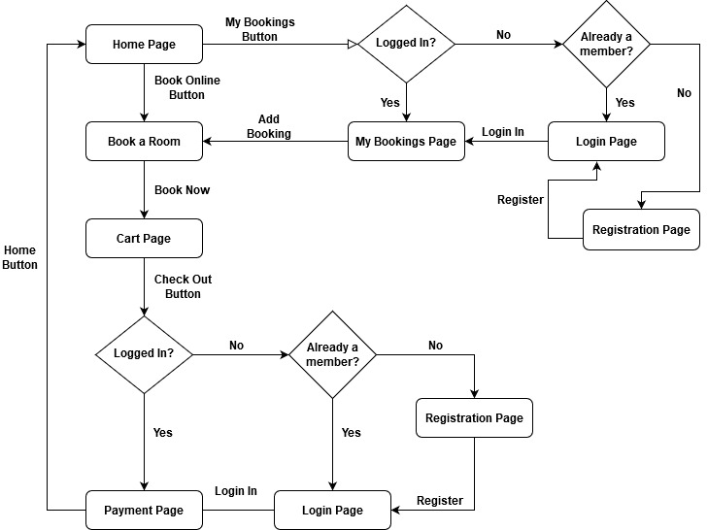

Fig 1: Flow of the website

# Pages In The Website

The **home page** of the website giving details about the hotel including information about the history of the hotel, different types of rooms available, the services provided, some glimpse of the Hotel’s infrastructure and the contact us information of the Hotel. This is where the user can perform almost all functionalities, like login room, booking a room, viewing my bookings etc.

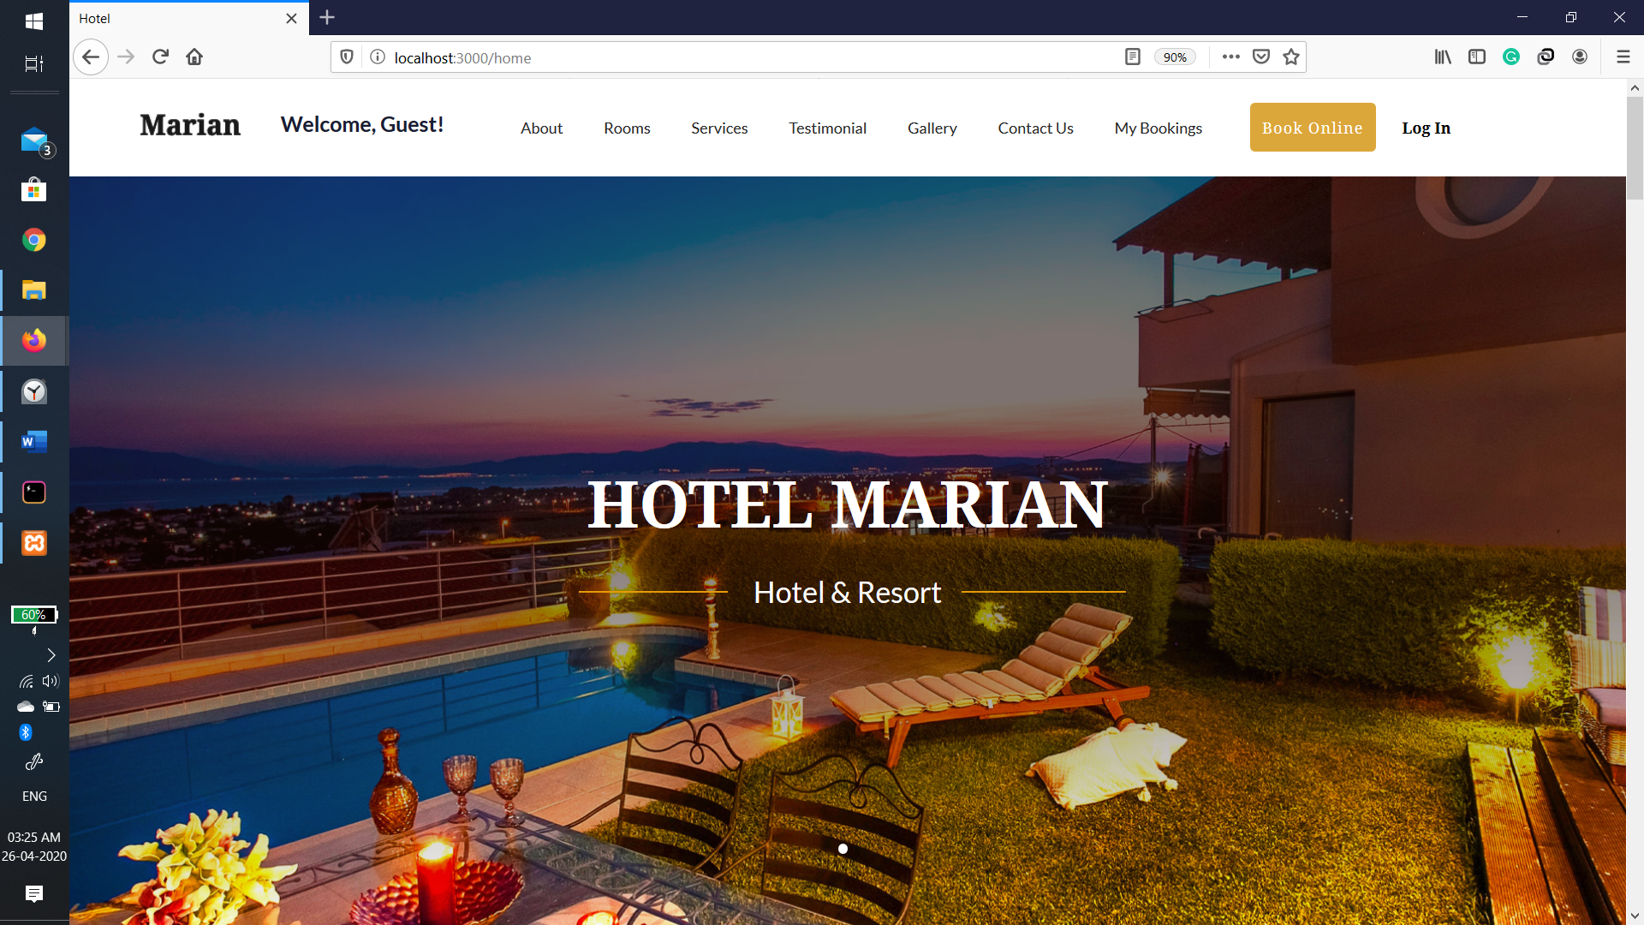

Fig 1: Home page

Each button on the top bar will scroll to the respective section of the page.

The Book Online button and all images of rooms when clicked on will take the user to the booking page.

Login button will redirect to the login page.

Clicking on My Bookings will show the currently logged user his/her bookings.

The **login page** allows the user to login in an already existing account, or if new to the website it also gives an option to redirect to the register page.

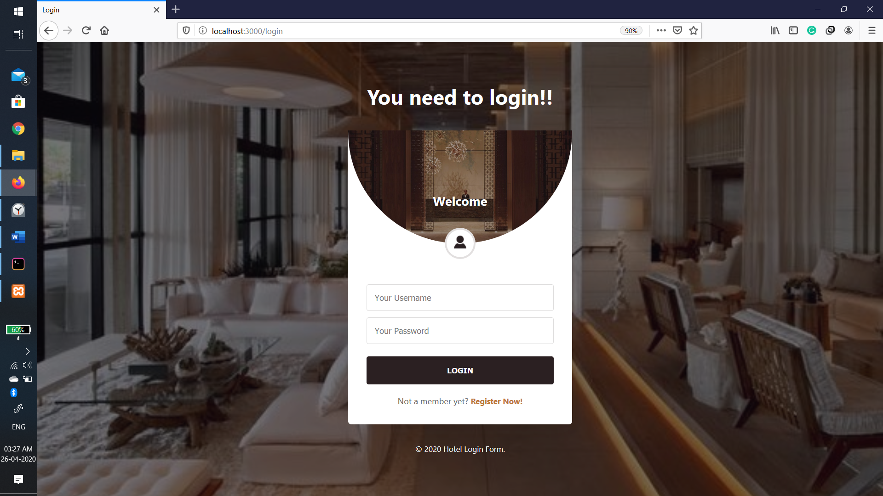

Fig 2: Login Page

Username and password are required fields.

Password will appear hidden.

The entered password is compared with the decrypted password fetched from the database

Will show error message when Username or password is invalid.

The **registration page** allows new users to register by filling out the following details about them, first name, Last name, Date of Birth, Gender, Email id, Phone number, username, Password, confirm Password.

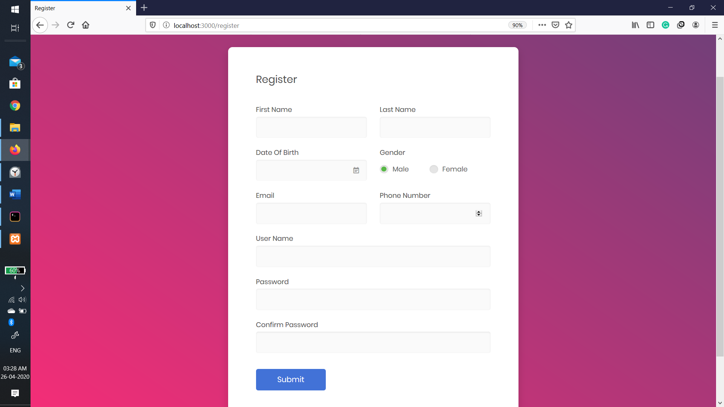

Fig 3: Registration page

All fields are required fields.

Birth date will accept only above 18 years.

Email id format is [mail@doamin.com](mailto:mail@doamin.com).

Phone number should be 10 digits.

The password should be at least 6 digits in length.

Password and confirm password should match.

The password in encrypted and stored in the database.

Email or username shouldn’t be already be in use by any other user.

The **booking page** is for users logged in or not, to fill the details as per their requirement, they need to fill the name of the guest checking in, The type of the room they want to stay in, Number of room of that type they need to book, the check in date, check in time, check out date.

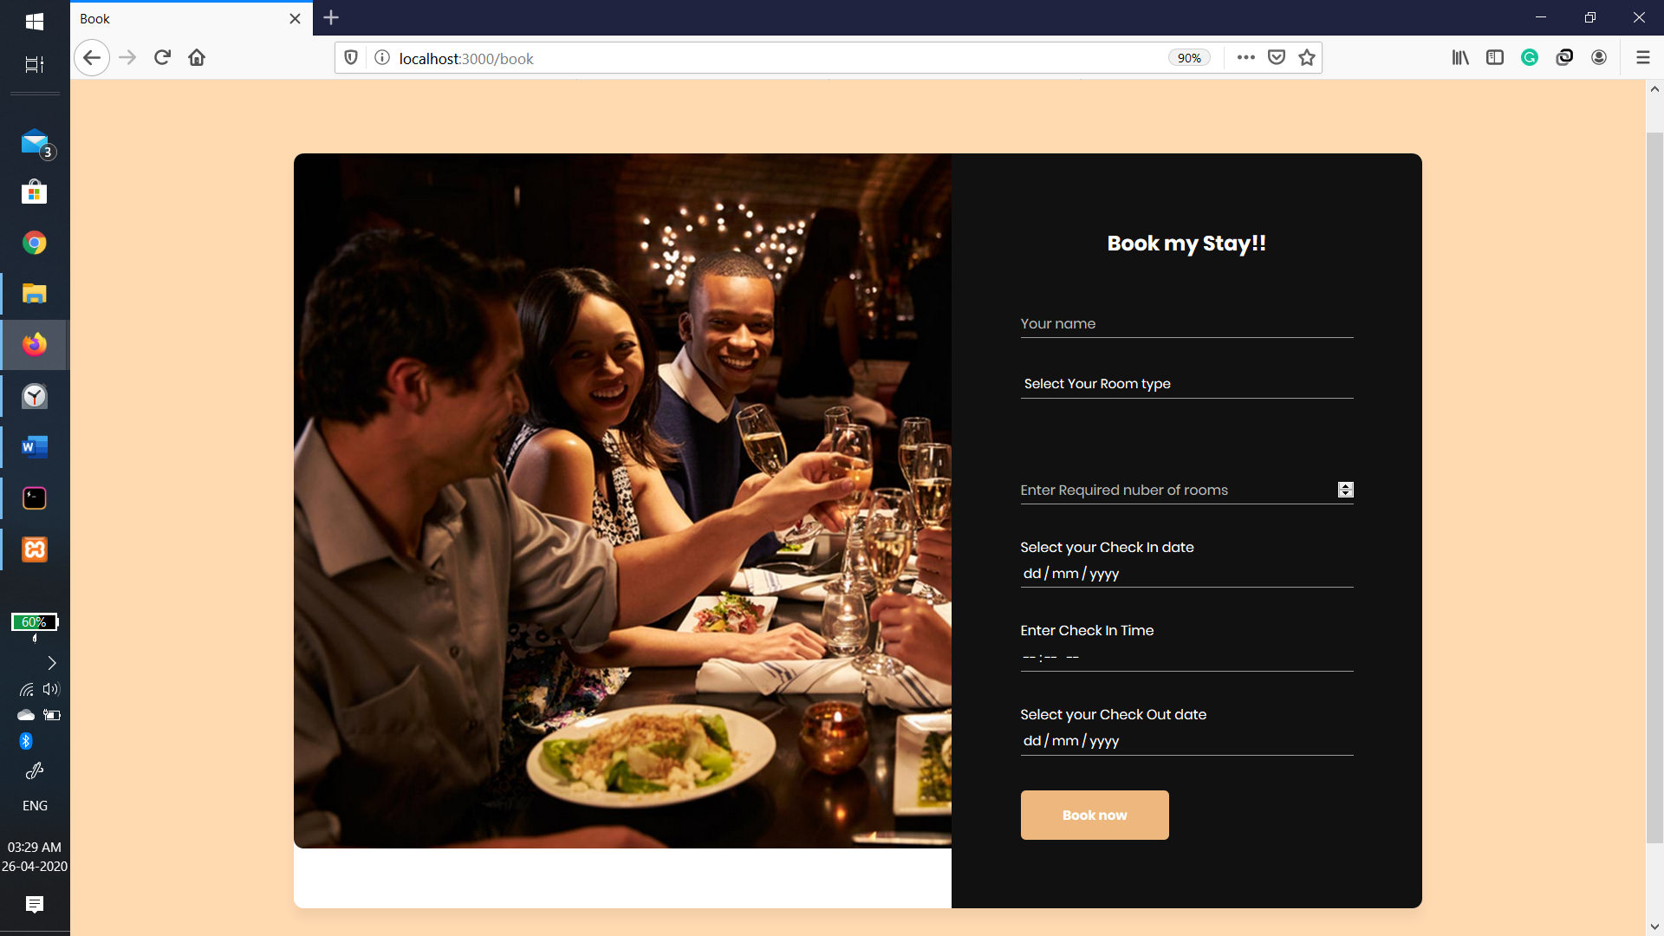

Fig 4: Booking Page

All fields are required fields.

Number of rooms can’t be negative.

Check in date can’t be before current date.

Check out date can’t be before check in date.

The **cart page** is meant to display to the user the details of their booking and the final cost of their stay for the number of days and the number of rooms booked. The checkout button will redirect a logged in user to the payment page, but if the user hasn’t logged in yet then they’ll be redirected to the login page.

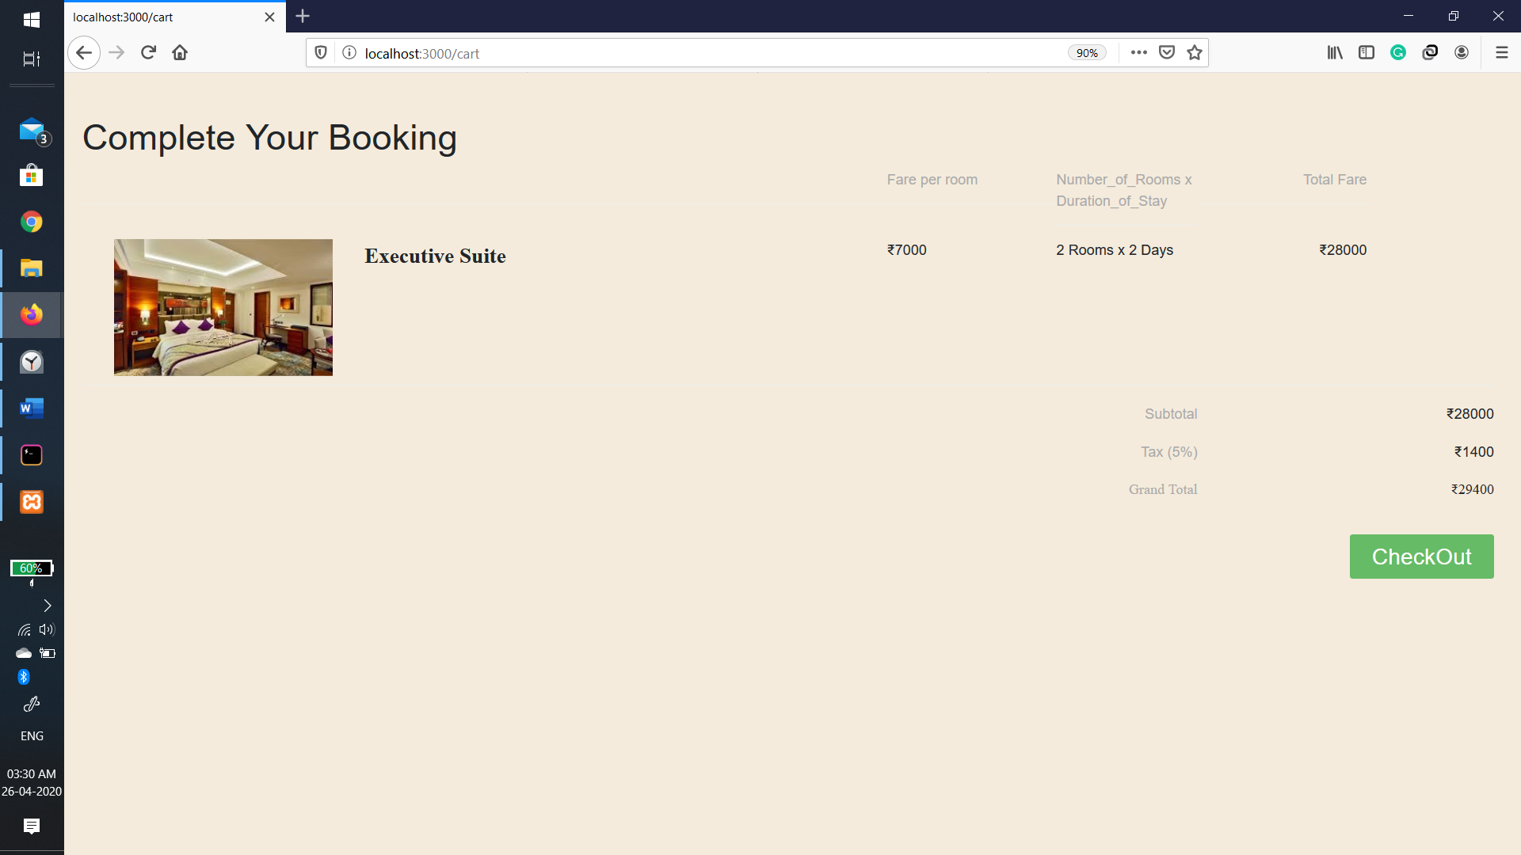

Fig 5: Cart Page

The **payment page** is used to take the details of the customer to confirm the booking, the page will take the Card number of the user, the expiry date of the card, the CVV code on the card and the name if the owner of the card. The final process payment button will book the room and redirect to the success page.

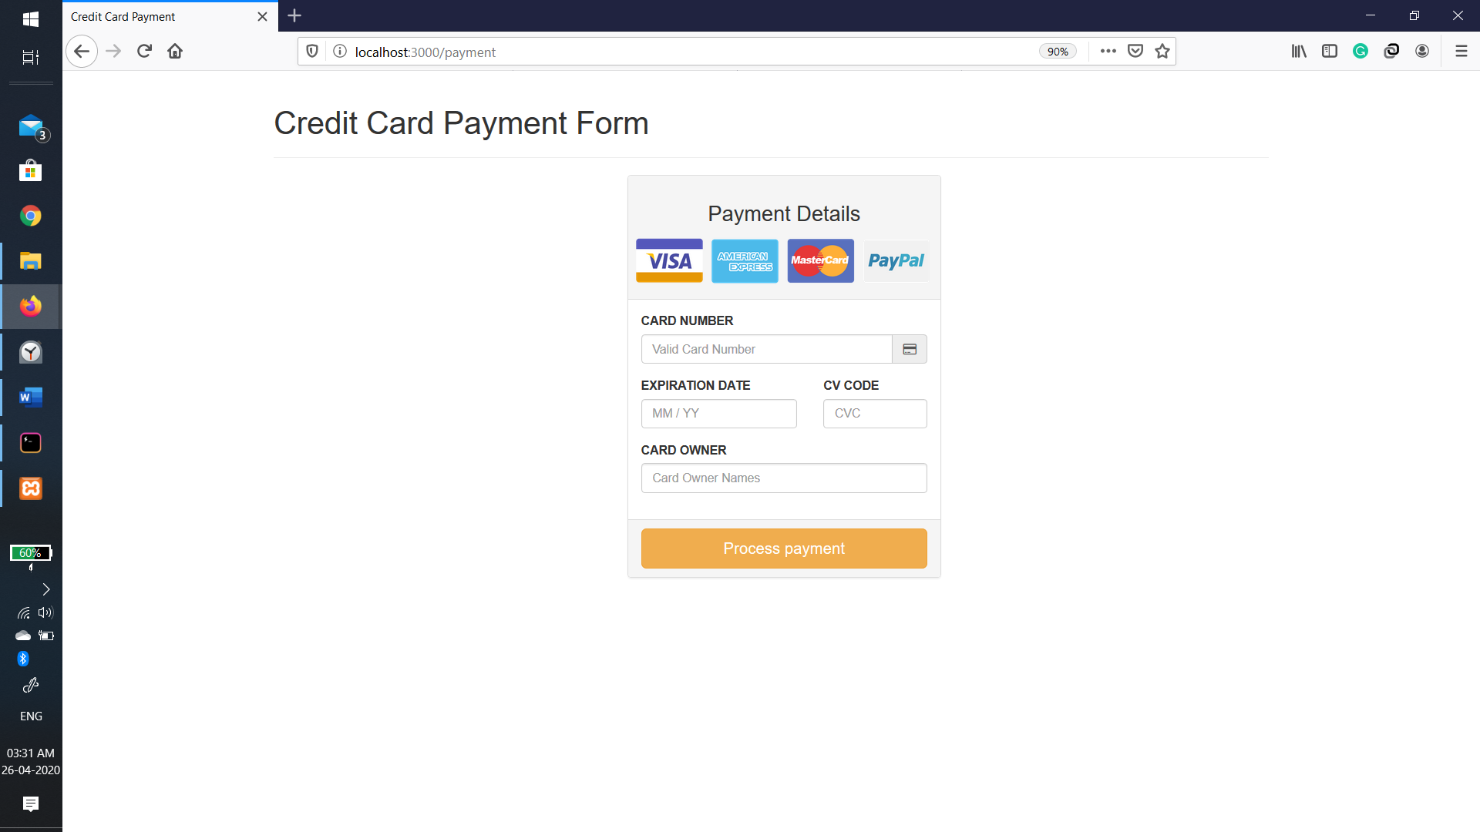

Fig 6: Payment Page

All fields are required.

The card number should be of 16 digits.

The Expiration date should be in format “MM/YY”.

The CVV code should be a 3-digit number.

The card number is stored with encryption.

**Success Page** greets the user by name and informs the user that the booking was successful with their check in date and time, along with a button that will redirect them to the home page of the website as a logged in user.

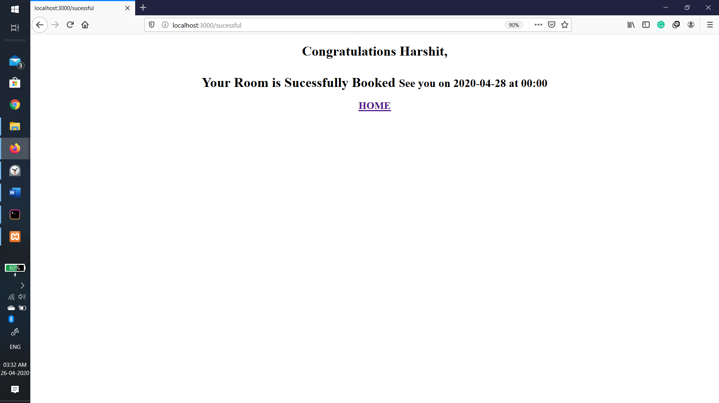

Fig 7: Success Page

My **booking page** is for the users to get the list of booking made by the user in the past, with the Tabulated data there is also an add bookings button which will redirect to the booking page, allowing the user to make another booking.

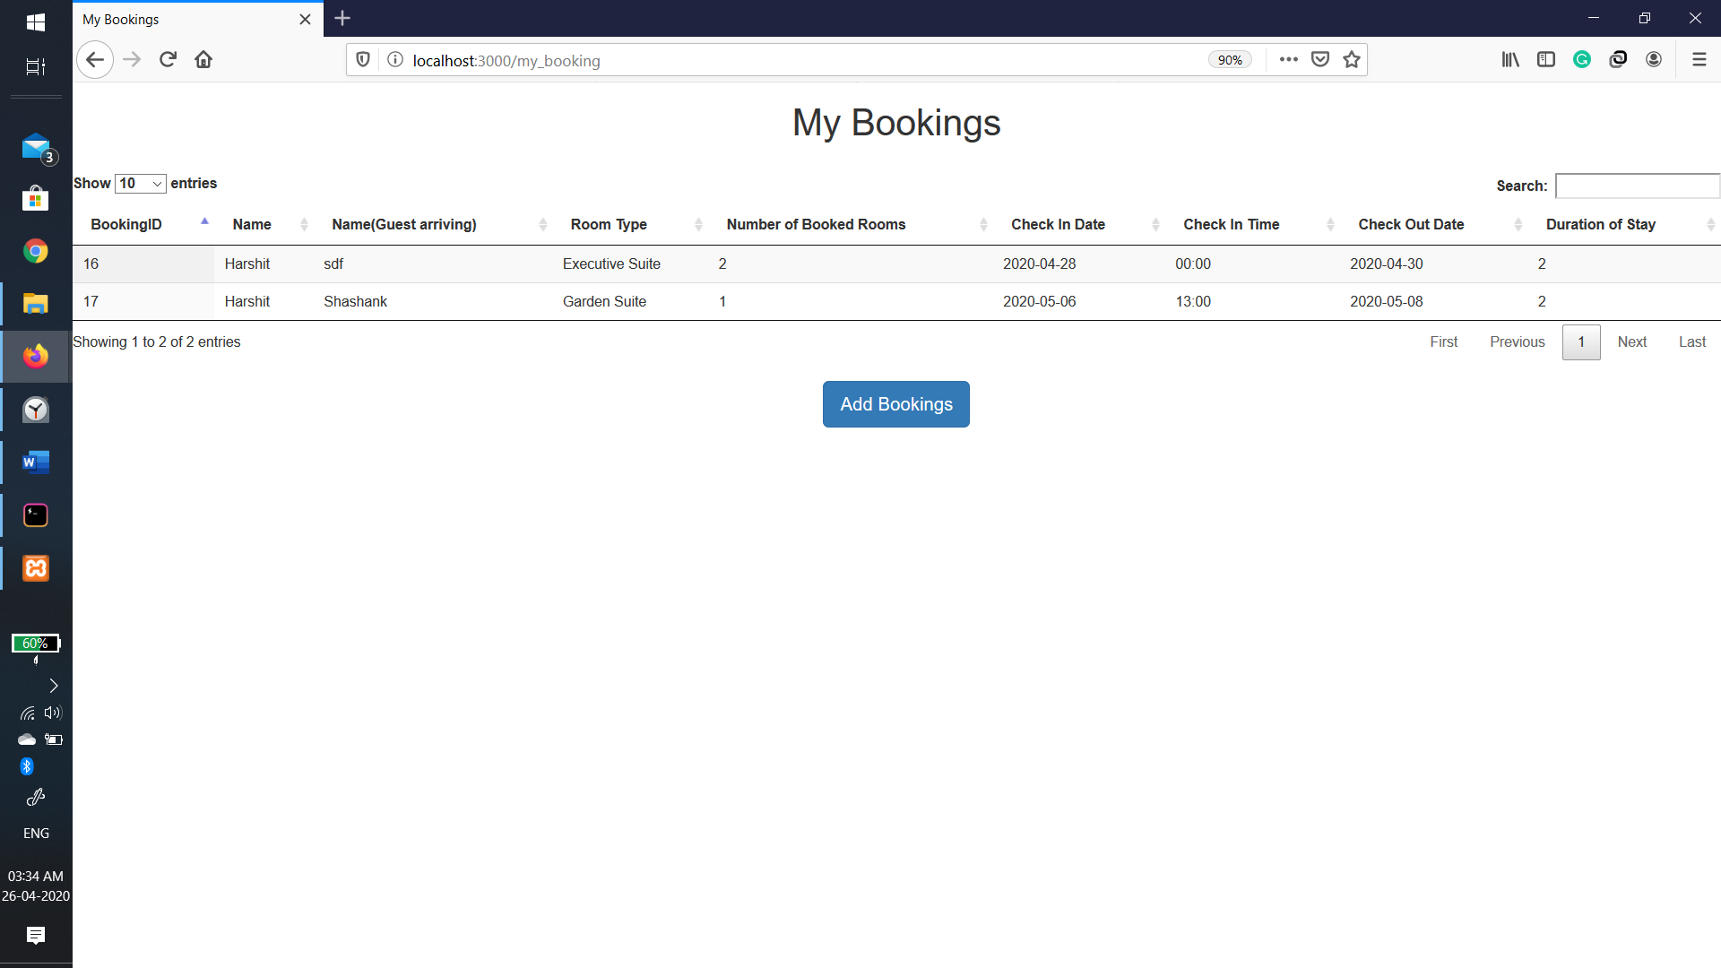

Fig 8: My bookings page

# BackEnd

The backend of the website was designed with Node js and the data is stored and accessed using MySQL database systems. The flow of the website, queries to the database was done with Node js and the database schema is showed in Fig 8.

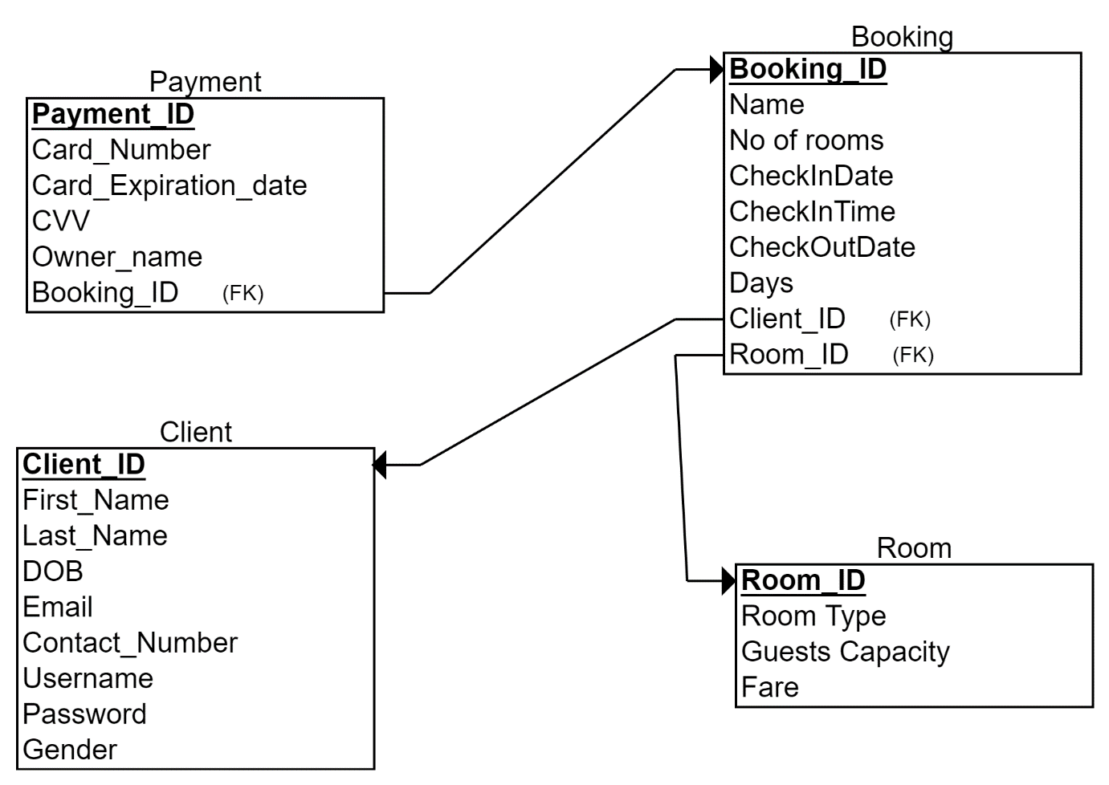

Fig 8: Data base Schema of the Website

The **clients table** consists of the details of each registered user, so note that the password has being encrypted, we can

see the structure and some example of this table. With the Client ID as the primary key.

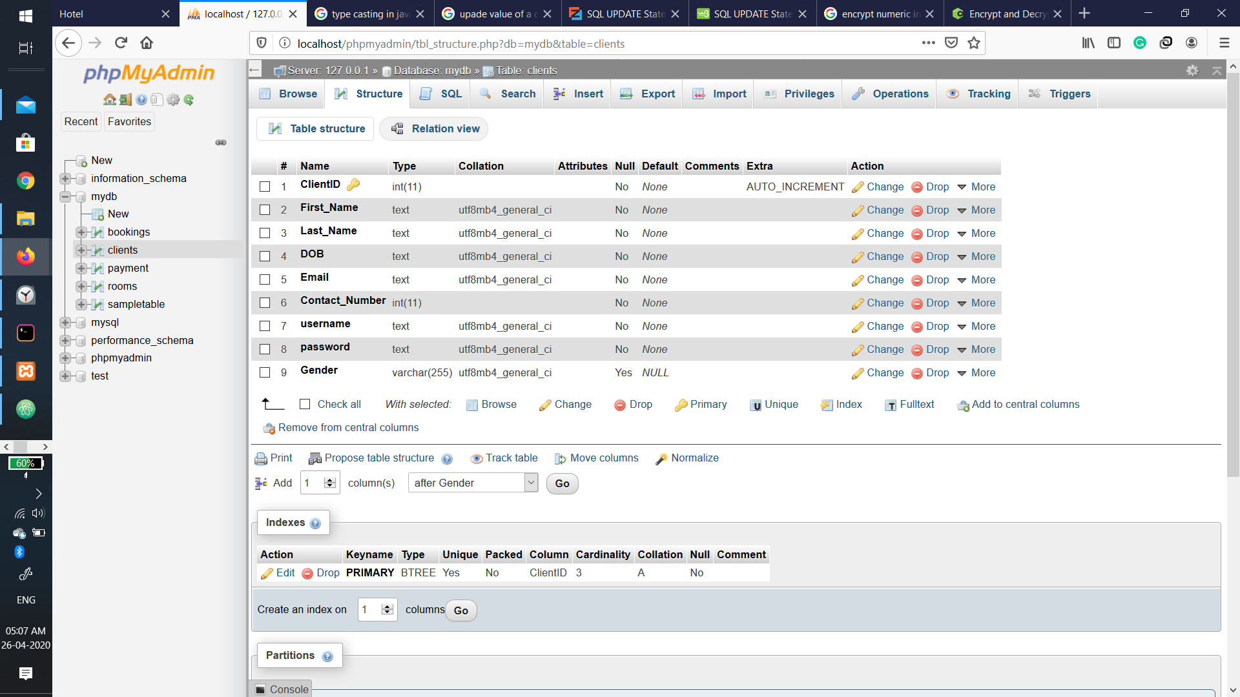

Fig 9: Structure of Table clients

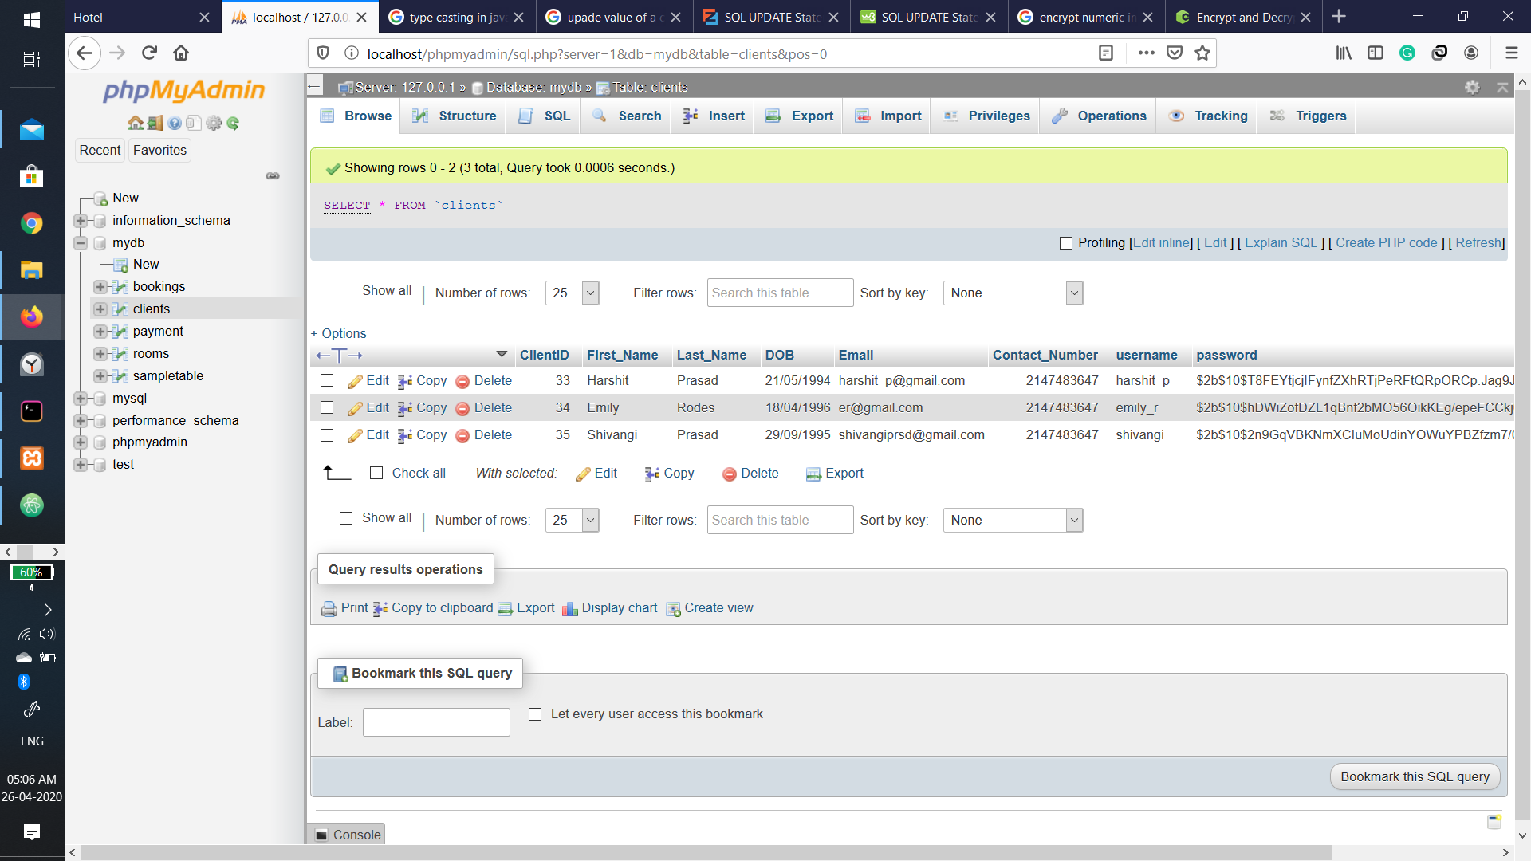

Fig 10: Examples in Table clients

The **table rooms** holds the data of each room , like the fare, availability, where room ID being the primary key. We can see their structure and examples in figure 11 and 12 respectively.

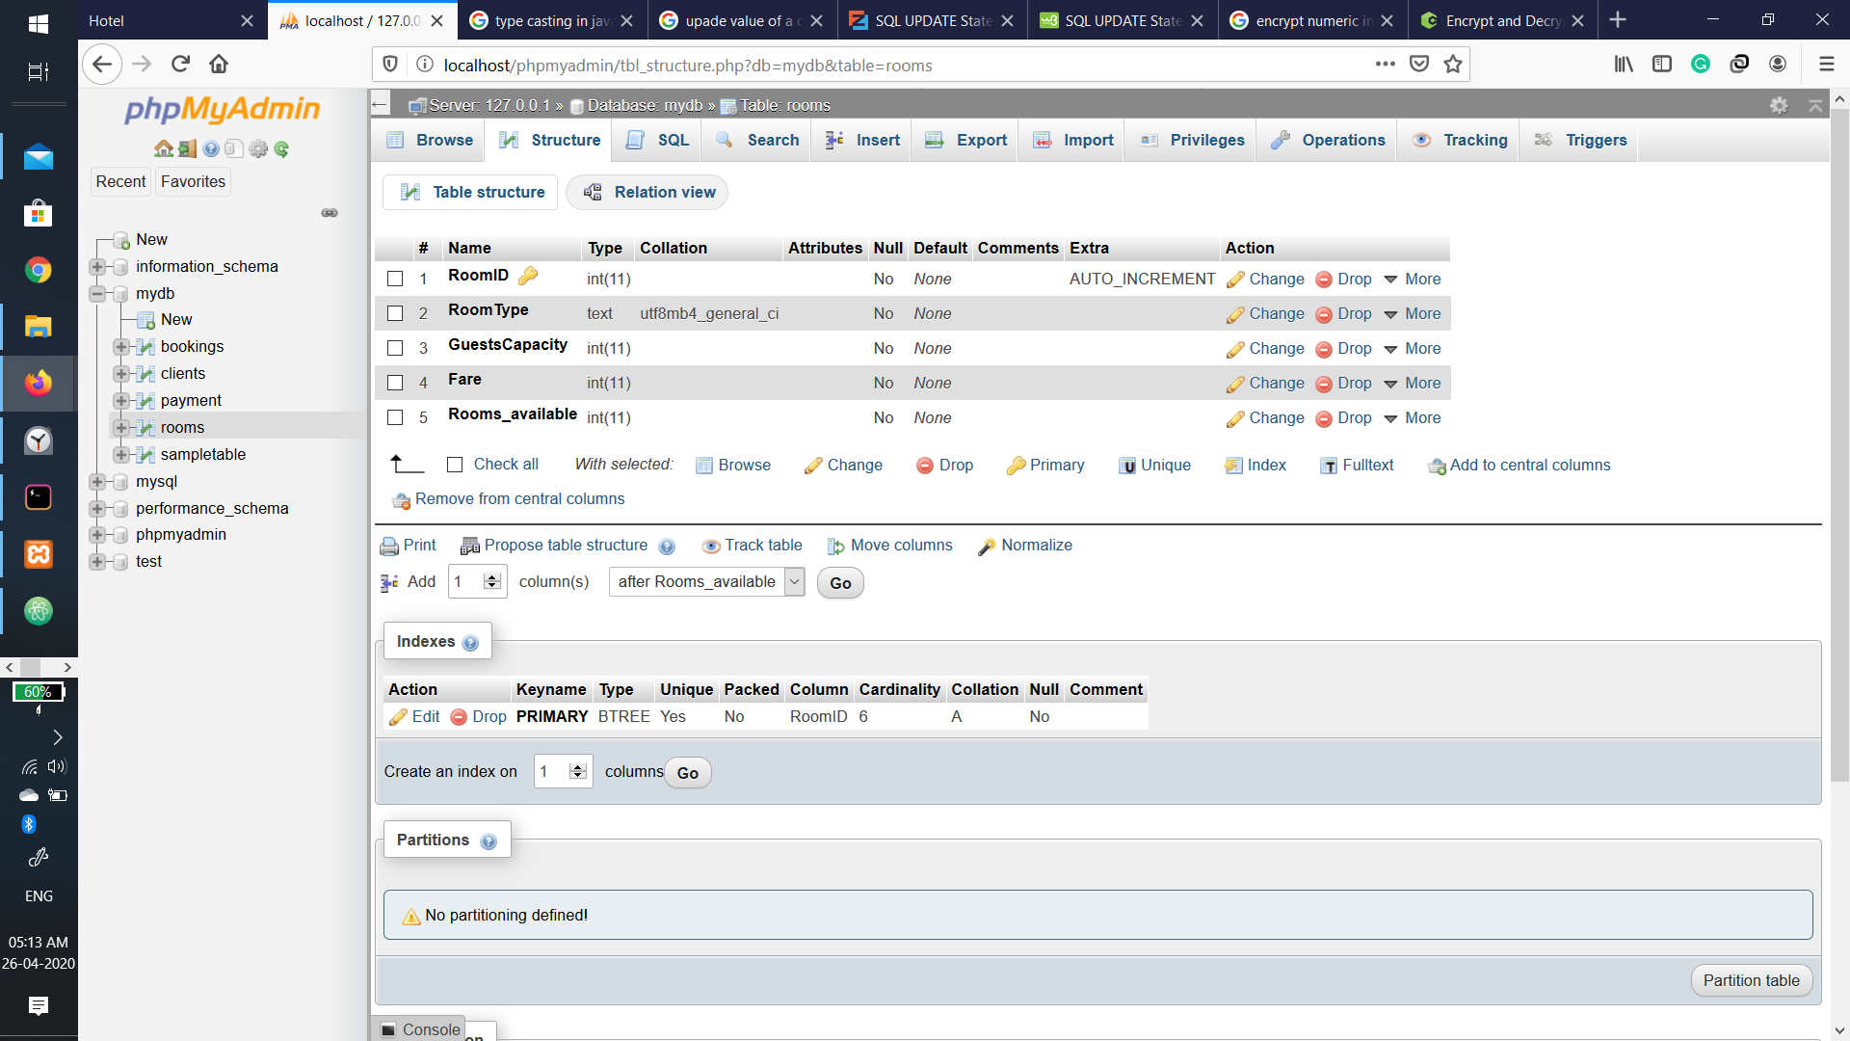

Fig 11: Structure of Table rooms

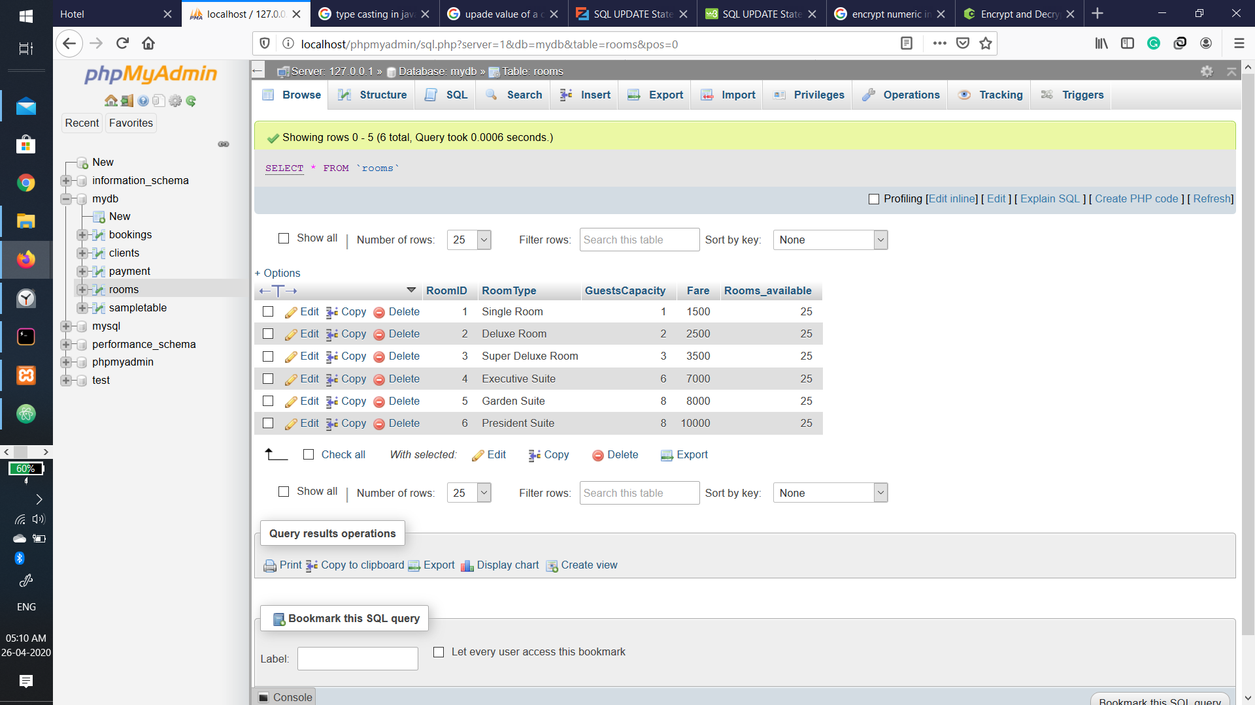

Fig 12: Examples in table rooms

The **bookings table** keeps the records of each booking, with the track of the client who made the booking as a foreign key ClientID. BookingID is the primary key here. We can see the structure and examples in figure 13 and 14 respectively.

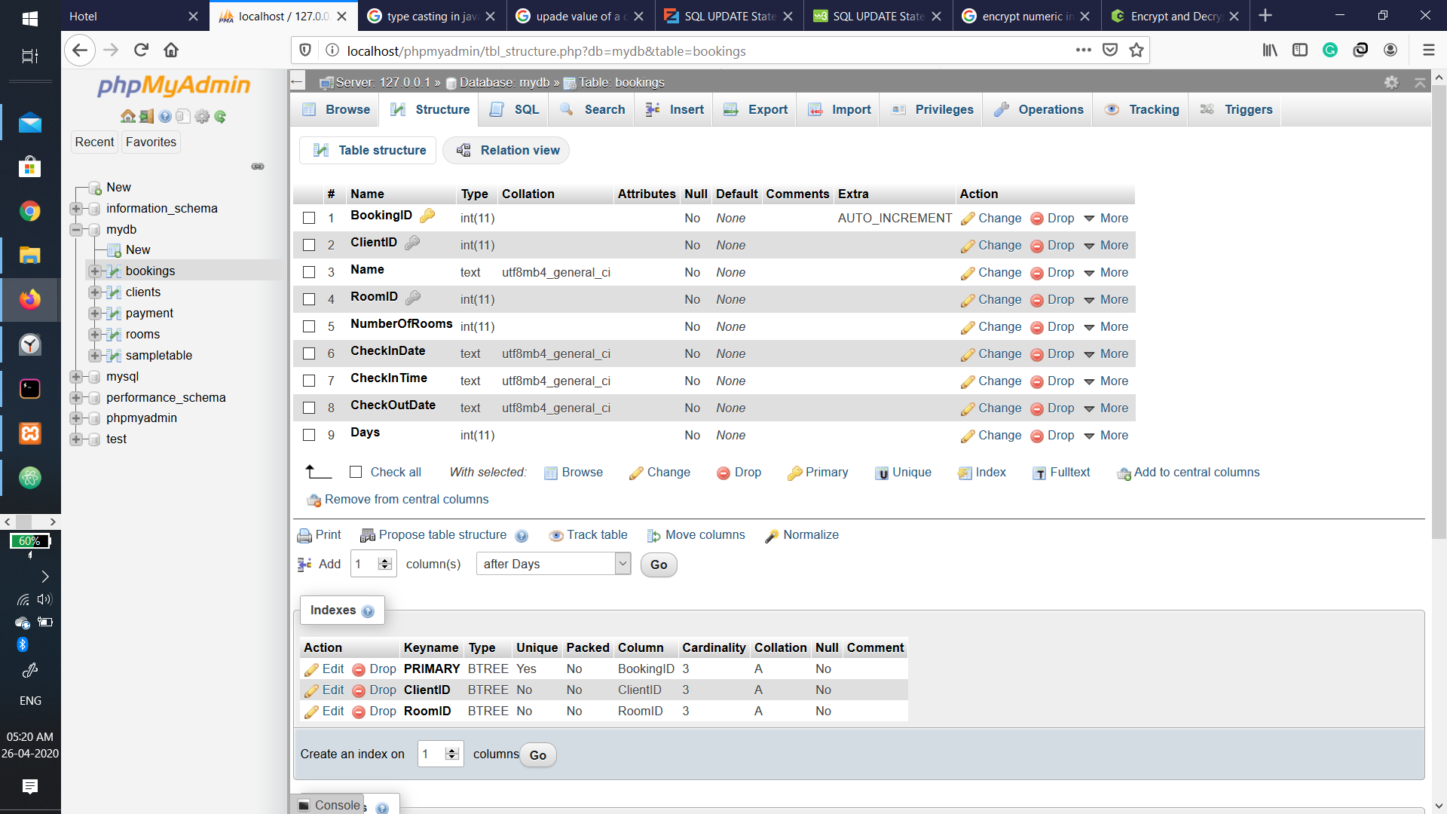

Fig 13: Structure of Table bookings

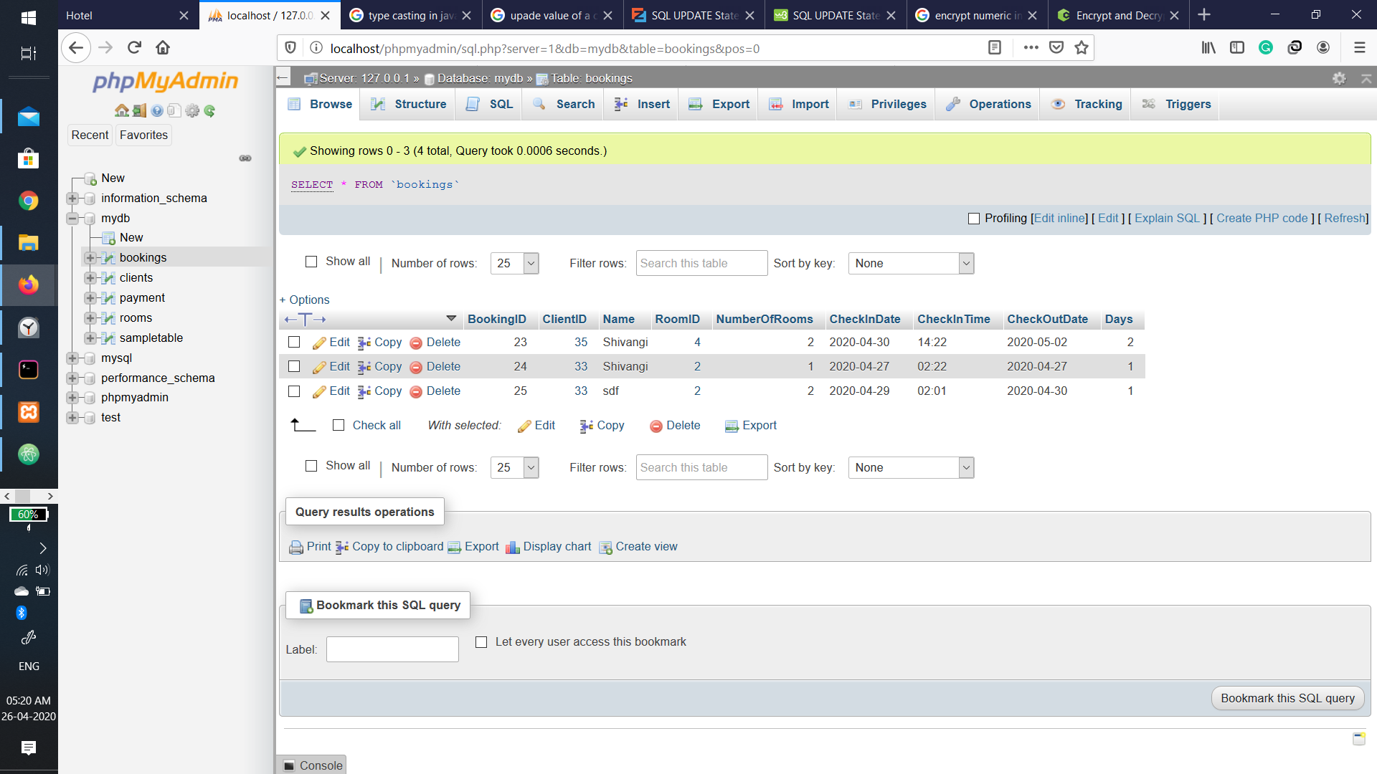

Fig 14: Examples in table bookings

The **payments table** keep records of payments of each booking. The card number has been encrypted due to security reasons, it has the primary key as PaymentID and bookingID has the foreign key in the table to relate it with the corresponding booking. The structure and examples of the table are given in figure 15 and 16 respectively.

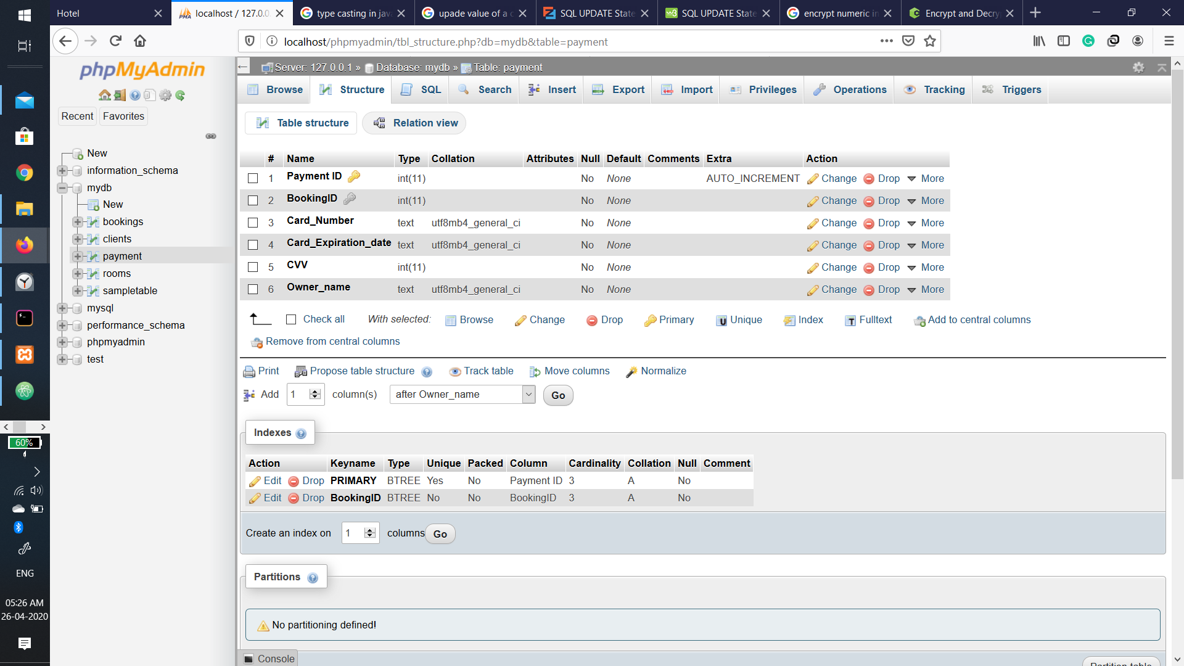

Fig 15: Structure of Table Payments

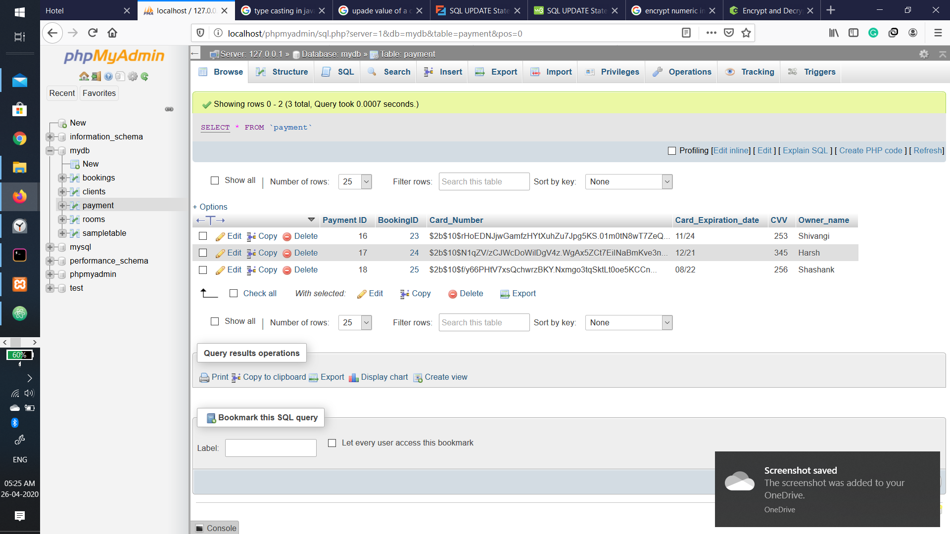

Figure 16: Examples of table payments

# Conclusion

A fully working website was developed, with the help of MySQL Node js and npm modules like, body-parser, express, by crypt, ejs, etc. for backend and HTML, CSS, JavaScript and bootstrap for front end of the website which allows customers to create profiles, book trips. Also allows hotel staff to view all bookings and change details of rooms like fare and availability.